CSC207 Project Individual Contribution

Group number: 15
GitHub username: hhcgoodluck
Link to GitHub repository: https://github.com/Jialun-Wei/team-project

Git Contributions

Link: https://github.com/Jialun-Wei/team-project/graphs/contributors
Graph: Below (username: hhcgoodluck)

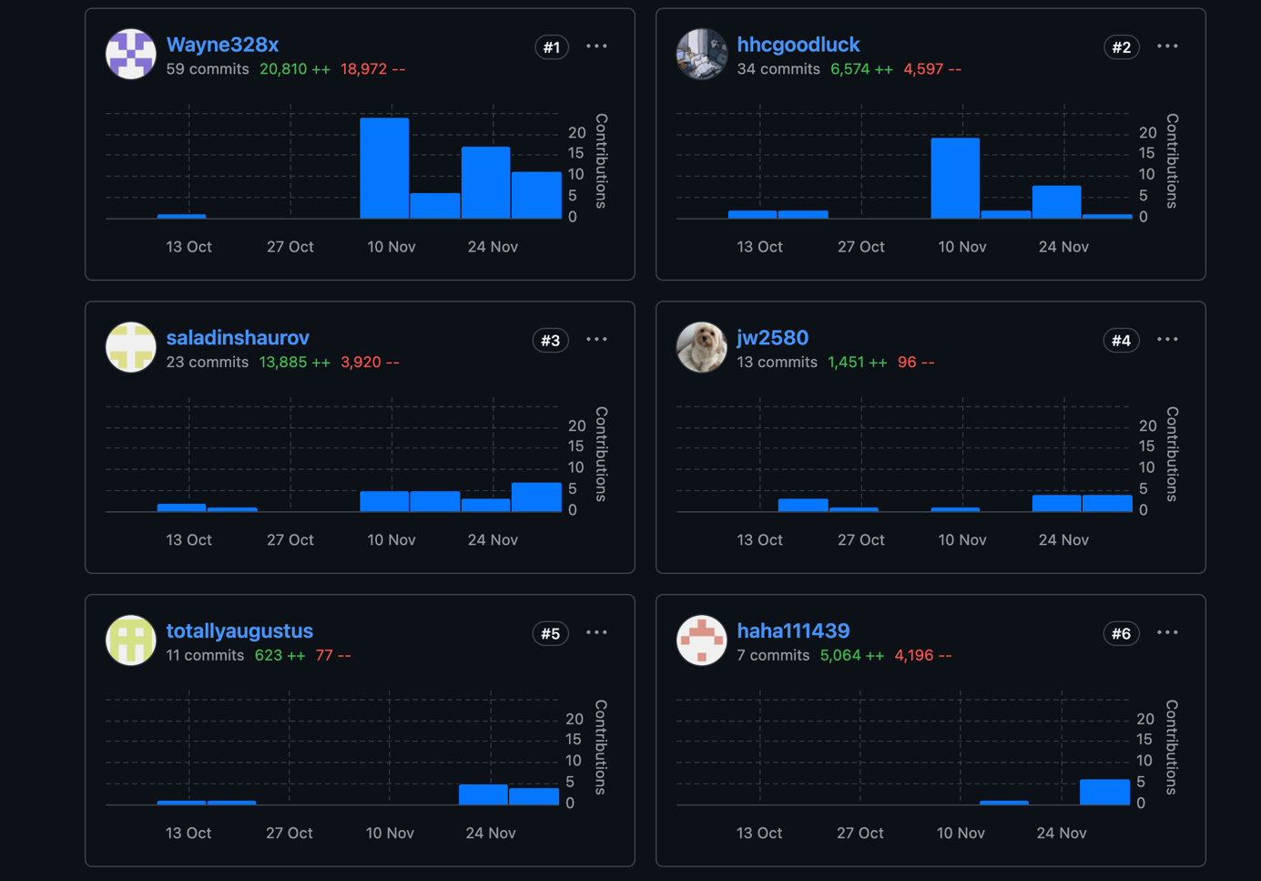

User story primarily responsible for Design
- Pull Request(s) related to the implementation of use cases related to this user story

[Branch: hhc_usecase5_branch --- Finishing all usecase5 specifications]
https://github.com/Jialun-Wei/team-project/commit/ddf1e7654e697827bba565a875398071b5bba802

[Branch: hhc_usecase5_refactor_branch --- Refactor after usecase3 and usecase4]
https://github.com/Jialun-Wei/team-project/commit/7547eb191c712749e82e6f45e5328267d165b3e1

https://github.com/Jialun-Wei/team-project/commit/22fd7d7562af952104f6f561511ff57866d174aa

[Branch: hhc_usecase5_test_branch --- Test files about usecase5]
https://github.com/Jialun-Wei/team-project/commit/69f64c0650270ed986c529bf2cb20c8fa7b58e5a

- Short paragraph describing the user story and related use cases

Related Use Case: #5

The use case allows users to quickly understand how their stock investments have performed over time. When the user selects “Stock Holdings,” the system retrieves their holdings and historical price data, calculates daily total cost, total value, profit, and profit rate, and visualizes these results through a trend line chart and a performance table.
If the user has no holdings, the system simply displays “No data available.” This provides a clear and intuitive overview of the user’s investment performance.

- Evidence of 100% code coverage for one use case interactor related to this user story

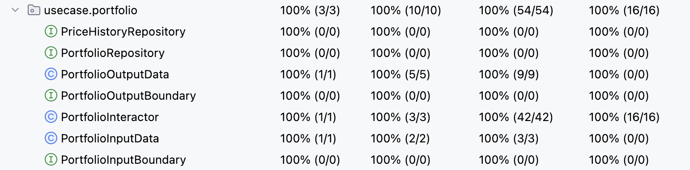

Another code contribution
- Links to Pull Requests demonstrating another significant code contribution

Original APP Dashboard Creation
[Branch: hhc_usecase5_branch --- Original Version of Dashboard Creation]
https://github.com/Jialun-Wei/team-project/commit/b789a70ee874a5782a8a3f5884fa8aebb5165151

https://github.com/Jialun-Wei/team-project/commit/e809fc3de89906b6540701410604f5f56d8c0a13

Fix Bugs in APP main files
[Branch: hhc_usecase5_refactor_branch --- fix the error about an incorrect initialization]
https://github.com/Jialun-Wei/team-project/commit/8033ff96a9bd8d2285aeb4d5df9165094afe00fd

Fix Errors about the Code Organization
https://github.com/Jialun-Wei/team-project/commit/d0bef5174bff01e0997b95e4de11bfe2f86c51a8

- Short paragraph describing this code contribution

Code Contribution1: Original version APP Dashboard Creation (before refactoring)

Code Contribution2: fix the error about an incorrect initialization order

This issue is an initialization order error, which means that the object tradingData was used before it was created or properly initialized. As a result, downstream components—such as TradingDataPortfolioRepository—received null or uninitialized dependencies.

Code Contribution3: fix the code organization

Wrong: Put the data access interface files into the outer layer
Correct: Data access interface file should be placed in the application/business rules layer

Two examples of code reviews performed

- [Code review #1]
https://github.com/Jialun-Wei/team-project/commit/304f6632b0f2930a4302cc29d1514577d323462b

- [Brief explanation #1]
Adjust the setting value of the initial principal to better simulate the operations in the use case and show the performance.

- [Code reviews #2]
https://github.com/Jialun-Wei/team-project/commit/7d2a76937d209893ef2974832b6ab759811ee0fa#diff-f65f09cdbb94712eeac384b289b867a8dfec149a483fe6b7e3fe1f33822339ef

- [Brief explanation #2]
Some Refactor suggestions related to following the clean architecture.

Other (Non-Code) Group Contributions

- [Short paragraph describing contribution to the overall design of your project]

Assisted teammates in designing the project’s use cases and proposed appropriate design patterns for each use case. Collected and summarized information on relevant APIs available for the project.

- [Short paragraph describing contribution to non-coding and non-design aspects of the project]

Promptly share relevant Piazza posts (e.g., issues encountered by other groups) in our team chat or raise our own questions on Piazza whenever we face problems during project development. And prepare the zoom meeting time.

Attendance / Communication / Peer Evaluations
None

